**Summary of Tableau Workbooks**

# 1. Ambulatory Access Workbook

* **Data Sources:** Federated data sources related to patient access and healthcare visits.
* **Worksheets:**
  + Completed Visits KPI
  + Completed Visits Trended
* **Dashboards:**
  + Ambulatory Access
  + Mortality
* **Calculated Fields:** None explicitly listed.

**Key Insights:**

* This workbook focuses on patient access to ambulatory (outpatient) services.
* The **Completed Visits KPI** worksheet likely tracks overall patient visit metrics.
* The **Completed Visits Trended** worksheet analyzes how patient access and visits change over time.
* It shares some connection with mortality tracking, indicating that patient access may be studied in relation to patient outcomes.
* The **Ambulatory Access dashboard** likely provides insights into patient scheduling, appointment completion rates, and potential access barriers.

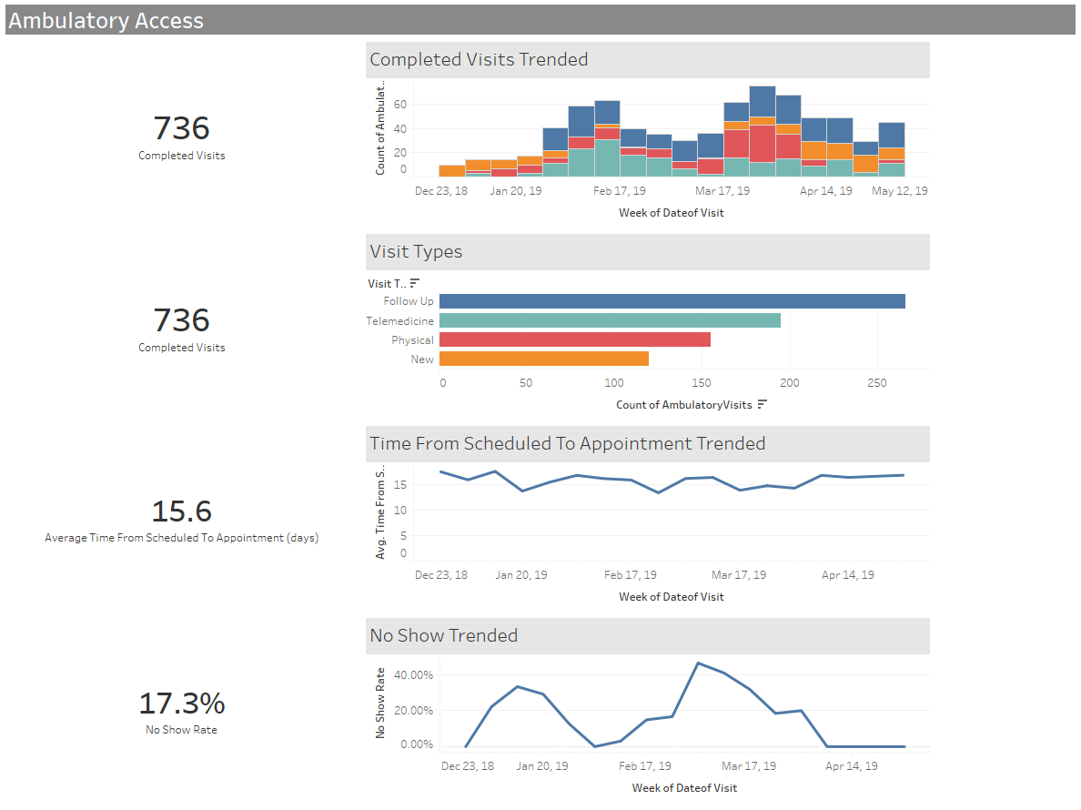

# 2. Mortality Workbook

* **Data Sources:** Includes multiple federated data sources used for analysis.
* **Worksheets:**
  + Completed Visits KPI
  + Completed Visits Trended
  + Mortality By Demographics
  + Mortality By Diagnosis
* **Dashboards:**
  + Ambulatory Access
  + Mortality

**Key Insights:**

* This workbook focuses on mortality rates and trends, likely providing insights on patient mortality based on different demographic and diagnostic categories.
* It includes KPI (Key Performance Indicator) dashboards to track completed visits and mortality trends over time.

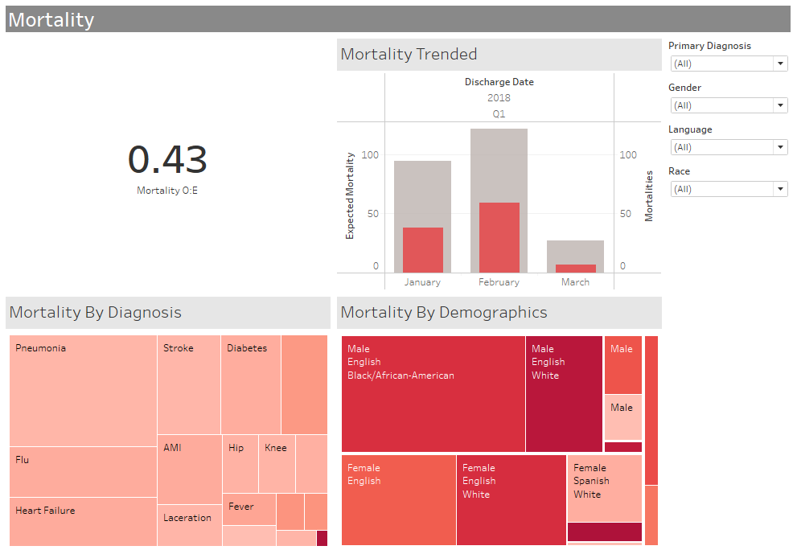

# 3. Hypertension Management Workbook

* **Data Sources:** Includes a mix of parameters and federated data sources.
* **Worksheets:**
  + BP Controlled By Demographics
  + BP Controlled Over Time
  + Hypertension Patient Breakdown
* **Dashboards:**
  + Ambulatory Access
  + Hypertension Management
  + Mortality

**Key Insights:**

* This workbook is focused on hypertension management, particularly tracking blood pressure (BP) control across different patient demographics and over time.
* The "Hypertension Patient Breakdown" worksheet may provide a segmentation of patients based on BP control and other risk factors.

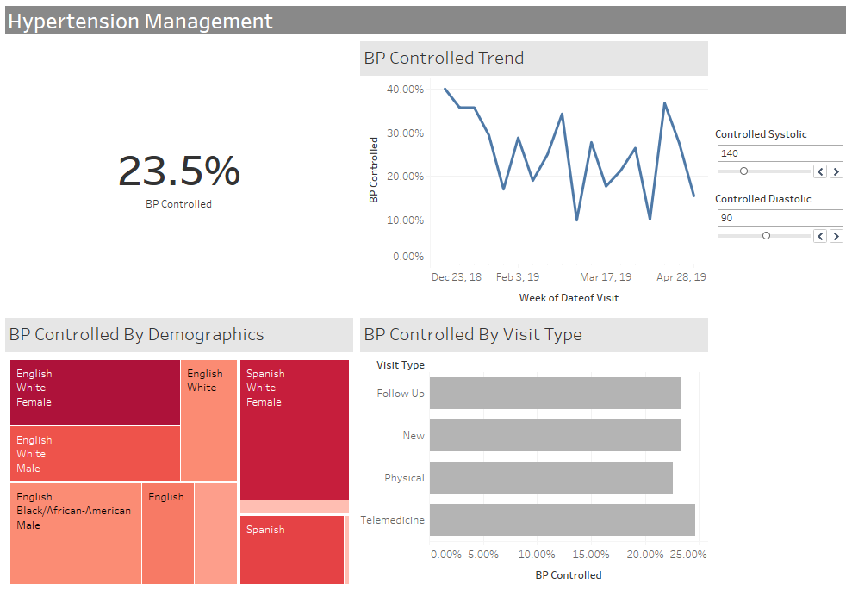

# 4. Length of Stay Workbook

* **Data Sources:** Federated data sources for hospital/clinical data.
* **Worksheets:**
  + LOS KPI (Length of Stay KPI)
  + Length of Stay Trended
  + O:E By Diagnosis (Observed to Expected Ratio)
* **Dashboards:**
  + Length of Stay

**Key Insights:**

* This workbook tracks patient length of stay (LOS), a key hospital performance metric.
* It includes trend analysis over time and compares observed vs. expected stay durations by diagnosis category.
* The KPI worksheet likely provides real-time tracking of LOS metrics.

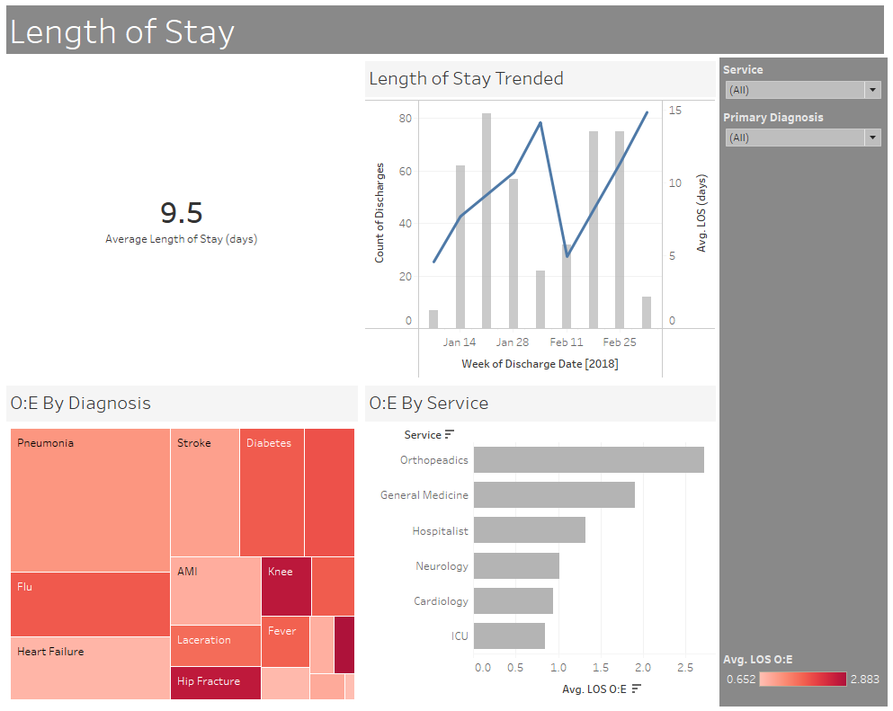

# 5. Readmissions Workbook

* **Data Sources:** Federated data sources similar to the Length of Stay workbook.
* **Worksheets:**
  + LOS KPI
  + Length of Stay Trended
  + O:E By Diagnosis
* **Dashboards:**
  + Length of Stay
  + Readmissions

**Key Insights:**

* This workbook appears to focus on hospital readmissions, which is a critical measure of healthcare quality.
* It shares some analysis elements with the Length of Stay workbook, possibly correlating readmissions with LOS data.
* The dashboards likely highlight trends in patient readmissions, identifying patterns and areas for intervention.

